Bent generalized cylinder

# Definition

A bent generalized cylinder is a shape with circular cross-section having a planar spine curve and varying radii along the spine.

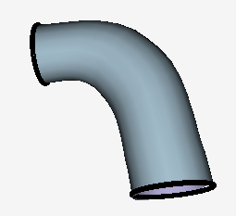

# Representation

## Parameters

Spine plane representation:

* , – 3D vectors representing an orthonormal basis for the spine’s plane
* – The “bottom” center of the primitive. This is the center of one of the end-point circles. “Top” and “bottom” are defined arbitrarily, based on the direction of the spine (explained later).

From now on, all parameters are 2D points/vectors defined by two parameters relatively to the plane spanned by , and passing through .

* and – the normal vectors of the top and bottom feature curves.
* Discrete spine parameters. For every point on the spine we have:
  + – the radius of the shape around point .
  + – Coordinates of the point on the spine.

**Definition**:

* This defines vectors in the spine’s plane.
* This defines points in the spine’s plane

## Internal constraints

* Orthonormal basis
* Normalized normals
* Normals parallel to the spine
* First spine point will be “bottom” center

## Feature curves

The bottom feature curve is the circle centered at having plane normal and radius .

The top feature curve is the circle centered at having plane normal and radius .

Those feature curves later participate in geo-semantic constraints (for example – orthogonal to other feature curve, or coplanar to other feature curve).

# Optimization method

## 2D spine computation

The output of this process is a set of spine points and a radius approximation for every point: .

Alexander wrote it, so he can describe it better than me.

## Objective function

We use the output of the previous procedure to construct the expression tree for the objective function. The objective function consists of the following terms:

Where:

* – The “circle to sketch fit” for the top and bottom feature curves. It’s the same as in cylinders and cones.
* – Least squares error between actual radii and approximated radii. That is,
* - Radii smoothness term which is the radii Laplacian norm:
* – The least squares error between spine 2D coordinates and the approximated spine. That is:
* - Spine smoothness term – the Laplacian norm:

This objective function is optimized subject to the internal constraints and any geo-semantic constraints this primitive has.